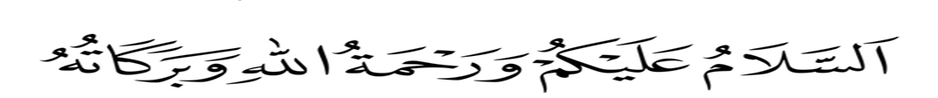
19th March 2020
Dear Parent/Carer,
Covid-19 Outbreak
Following on from my last update, I am now writing to let you know that we have now been instructed to close the school to almost all children after this Thursday until further notice.
As advised by the government, we will do all we can to stay open for the children of key workers (e.g. NHS staff, police, others in frontline services).
We are waiting for the government to publish more information on what this means, but it would help us in the meantime if you could let us know if you think your child may fall into one of these categories. Please email us on head@assunnahschool.co.uk or ismahaan@assunnah.co.uk or myusuf@assunnahschool.co.uk We’ll be in touch again as soon as we are sure who this does apply to.
All other children will need to stay at home, so we ask that you do not send your child into school from Friday onwards.
Please note that this is a national closure – as you may have heard in the news – so while it is a challenging situation, we are not alone. We’ll re-open fully as soon as we can and will let you know when this is by text message, and class dojo.
What we’ll continue doing while your child is at home
Your child’s learning is of course important to us, so we’ll continue to help your child to learn. The timetable below is a guidance and you can adapt according to your family setting Insha Allah.
Distance Learning Timetable
Time | Monday | Tuesday | Wednesday | Thursday | Friday
900-9.15 | Adhkar | Adhkar | Adhkar | Adhkar | Adhkar
9.15-10.00 | Qur’an | Qur’an | Qur’an | Qur’an | Qur’an
10.15-10.30 | Break | Break | Break | Break | Break
10.30.-11.30 | English | English | English | English | English
11.30 -12.30 | Maths | Maths | Maths | Maths | Maths
12.30-1.00 | Reading | Reading | Reading | Reading | Reading
1.30-2.30 | Lunch | Lunch | Lunch | Lunch | Lunch
2.30-3.30 | Project Work  Science | Project Work  Science | Project Work  Geography | Project Work  History | Project Work  History
3.30-4.00 | Handwriting | Handwriting | Handwriting | Handwriting | Handwriting

You need to collect learning packs from school as well as login in details for classroom secrets and oxford owl reading from the class teachers.
What we won’t be able to go ahead with
- School Science Workshop on 23rd March 2020
- Science Exhibition 1st April 2020
- End of term exams Week beginning 3rd April 2020
This is as much as we know right now and we appreciate your continued patience with as we deal with this ever-changing situation. We understand that this latest news will have an impact on you and your family and it’s far from ideal, but we’ll continue to keep in touch with any updates as the situation develops.
If you want to get in touch to share any concerns, please don’t hesitate to do so via [insert relevant contact details here].
And remember: if you or your child feels ill and you want to know what to do next, please use NHS 111 online.
Jazak Allah Kheir again for your continued support, and we will be in touch with more information when we can.

Hodan Yussuf
Headteacher

