Behaviour Policy

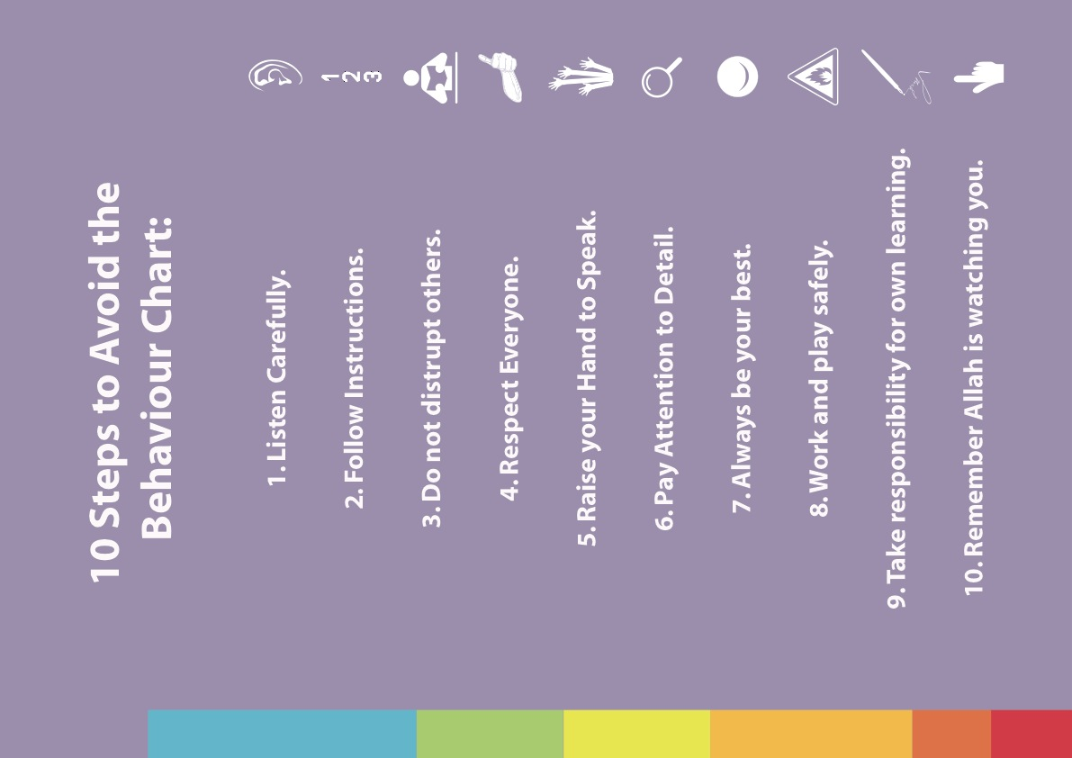
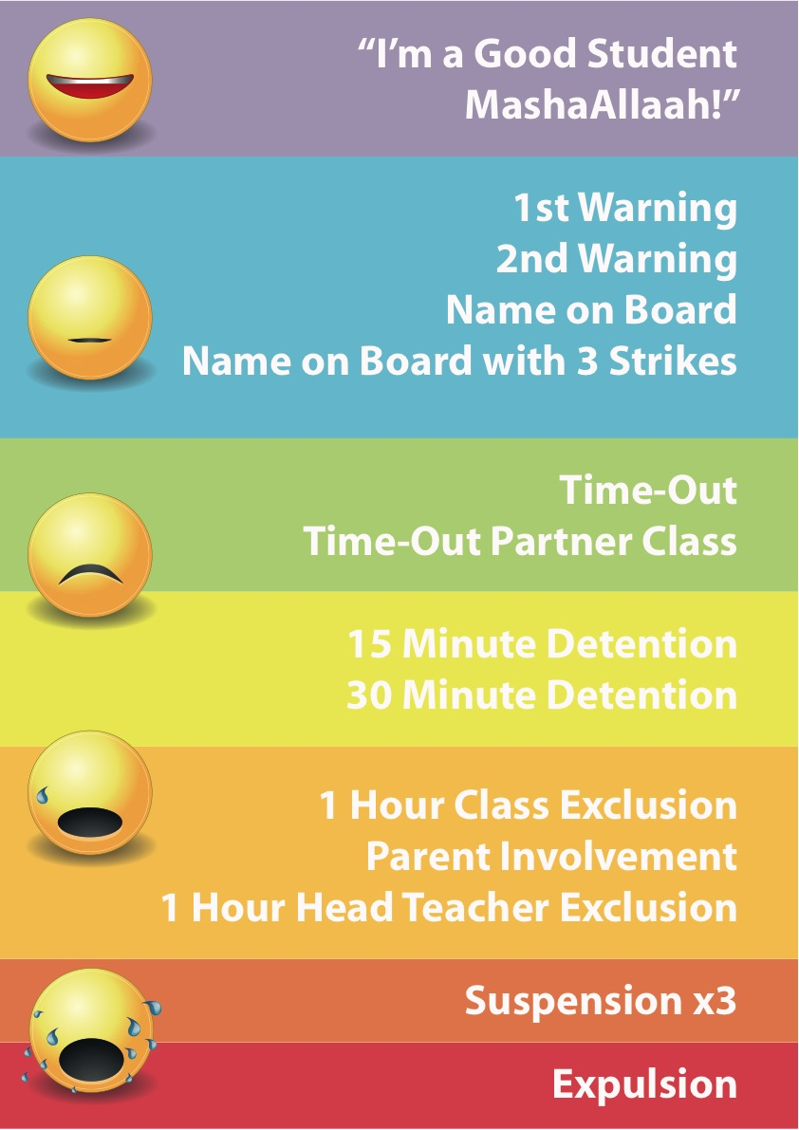

Types of Misbehaviour | Specific Examples | Sanctions
Disruptive Behaviour | Shouting out | Verbal warning
 | Talking in assembly
 | Running indoors
 | Talking/messing about during lesson and quiet times
Disobeying rules | Talking in assembly
 | Inappropriate noise whilst moving
 | around corridors
 | Running indoors
 | Running on paths outside
 | Inappropriate behaviour in quiet area
Silly behaviour that could endanger themselves or others, or that interferes with learning | Throwing equipment | Name on Board straight away (can be rubbed off)
 | Hiding equipment
 | Tripping people intentionally
 | Skidding on ice / hall floor
 | Kicking lunchboxes
 | Running in and out of toilets
Aggressive behaviour towards another child | Pushing / Kicking / Spitting / Biting / | Name on Board straight away with 3 strikes (cannot be rubbed off)
 | Pinching / Hitting
 | Snatching possessions / Pulling
 | clothing / Throwing missiles
Verbal abuse towards another child | Name calling
 | Malicious gossip
 | Aggravating other children intentionally
Lack of co-operation | Answering back
 | Arguing with adults
Defacing natural environment | Fence Posts | 15 minute Detention
 | Plants / Trees / Shrubs
 | Holes in fields
 | Swinging gates and fences
Intolerable verbal abuse | Verbal abuse of a sexual nature | 30 minute lunch detention
 | Swearing at peers / theft
Violent behaviour | Hitting / Hurting / Throwing Stones | 1 hour class inclusion & Parental involvement
 | or other incident resulting in first aid treatment
Defiant refusal of a reasonable request | Saying no when asked by adults
 | Repeated failure to co-operate when Asked
 | Defiant refusal including abusive or
 | disrespectful language
Misbehaviour towards school | Deliberate damage to any school | Parental involvement & Suspension
 | equipment
 | Walls / Graffiti
 | Toilets
 | Scratching Furniture
 | Defacing school / library books
Verbal abuse towards adults | Swearing | Suspension
 | Name calling
Threatening behaviour towards adults | Verbal intimidation
 | Physical threat
 | Throwing objects
 | Kicking walls / objects
Physical abuse of staff / adults
 | Kicking / Hitting / Spitting / Biting

