Assunnah Whiterose Calculation Policy

This guidance has been developed from the White Rose Calculation Policy: working document, which was written as a guide to indicate the progression through Addition, Subtraction, Multiplication and
Division in Years 1– 6.
This guidance is our recommendation, in line with the Surrey Plus Maths Hub Primary Subject Knowledge Enhancement Course content.
We welcome any suggestions to this document and are always looking to refine and improve where possible. We hope you find it useful!

 | Objective | Concrete | Pictorial |  | Abstract
Year 1 | Number bonds of 5, 6, 7, 8, 9 and 10 | 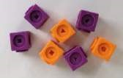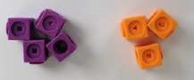  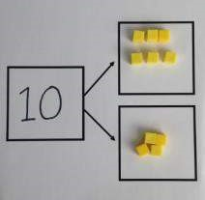  Use cubes to add  two numbers  together as a  group or in a bar.  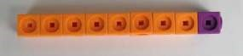 | 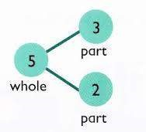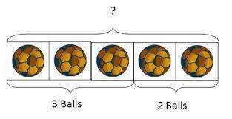  Use pictures to add two numbers together as a group or in a bar.  3 2 | - + 3 = 5  - + 2 = 5  5 = 3 + 2  5 = 2 + 3  Use the pa abstract. | 2  3  rt  -  part  -  whole diagram  as shown above to move into the
 | Counting | 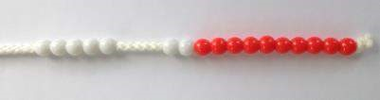  Start with the larger number on the bead string and then count on to the smaller number 1 by 1 to find the answer.  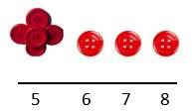 | Use a number line to count on in ones.  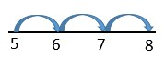 | 5 + 3 = 8

 | Objective | Concrete | Pictorial |  | Abstract
Year 1 | Regrouping to make 10 | 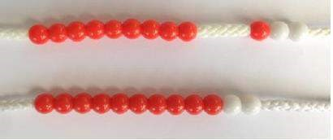  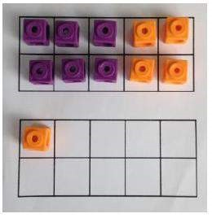  6 + 5 = 11  Start with the bigger number and use the smaller number to make 10. | 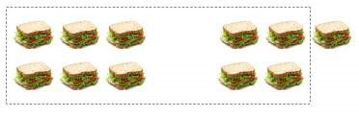  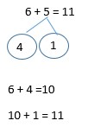 |  | 6 + 5 = 11
Year 2 | Adding 3 single digit numbers | 4 + 7 + 6= 17  Put 4 and 6 together to make 10. Add on  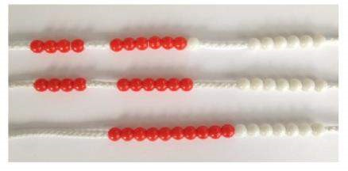  7.  Following on from making 10, make 10 with 2 of the digits (if possible) then add on the third digit. | +  +  Add together three gro objects. Draw a picture to recombine the groups to make 10. | +  +  +  ups of | 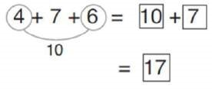  Combine the two numbers that make 10 and then add on the remainder.
 | Objective | Concrete | Pictorial | Abstract
Year 2 | Column method without  regrouping | Add together the ones first, then add the tens. Use the Base 10 blocks first before moving onto place value counters.  24 + 15 =  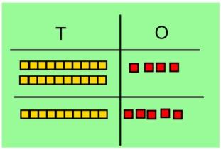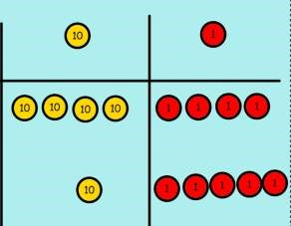44 + 15 = | After physically using the base 10 blocks and place value counters, children can draw the counters to help them to solve additions.  10  s 1s | 24 + 15 = 39  24  + 15  39
 | Column method with regrouping | 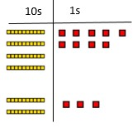  Make both numbers on a place value grid.  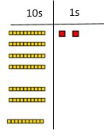  Add up the units and exchange 10 ones for 1 ten. | Using place value counters, children can draw the counters to help them to solve additions.  10  s 1s  10  s 1s | 40 + 9  20 + 3  60 + 12 = 72

 | Objective | Concrete | Pictorial | Abstract
Year 3/4 | Column method with regrouping | Make both numbers on a place value grid.  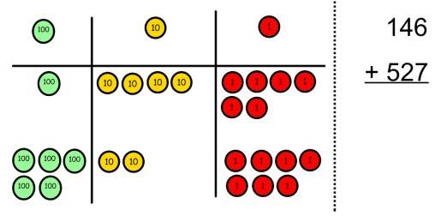  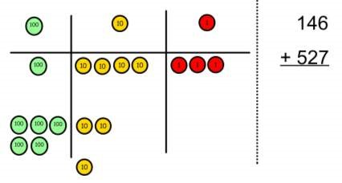  Add up the units and exchange 10 ones for 1 ten.  As children move on to decimals, money and decimal place value counters can be used to support learning.  NB By Year 4 children will progress on to adding four digit numbers. | 100s 10s 1s  100s 10s 1s  Children can draw a pictoral representation of the columns and place value counters to further support their learning and understanding.  NB Addition of money needs to have £ and p added separately. | 100 + 40 + 6  500 + 20 + 7  600 + 70 + 3 = 673  As the children progress, they will move from the expanded to the compacted method.  146  + 527  673  1  As the children move on, introduce decimals with the same number of decimal places and different. Money can be used here.
Year 5/6 | Column  method with  regrouping | Consolidate understanding using numbers with more than 4 digits and extend by adding numbers with up to 3 decimal places.

 | Objective | Concrete | Pictorial | Abstract
Year 1 | Taking away  ones | Use physical objects, counters, cubes etc. to show how objects can be taken away.  4 – 2 = 2 | Cross out drawn objects to show what has been taken away.  4 – 2 = 2 | 4 – 2 = 2
 | Year 1  Counting back | Make the larger number in your subtraction. Move the beads along your bead string as you count backwards in ones.  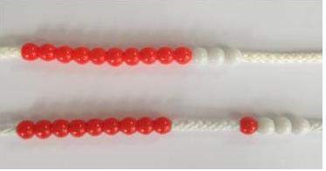  13 – 4 = 9 | Count back on a number line or number track  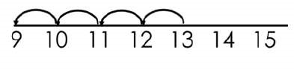  Start at the bigger number and count back the smaller number, showing the jumps on the number line. | Put 13 in your head, count back 4. What number are you at?  Use your fingers to help.
 | Find the difference | 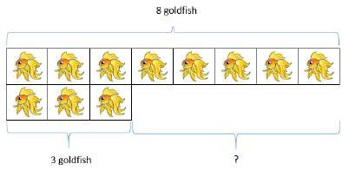  Compare amounts and objects to find the difference.  Use cubes to build towers or make bars to find the difference. Use basic bar models with items to find the difference. | 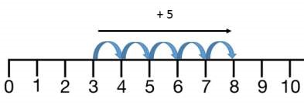  Count on to find the difference.  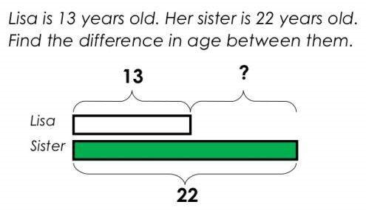  Draw bars to find the difference between 2 numbers. | Hannah has 8 goldfish.  Helen has 3 goldfish.  Find the difference between the number of goldfish the girls have.

 | Objective | Concrete | Pictorial | Abstract
Year 2 | Column method without regrouping | 75 – 42 = 33  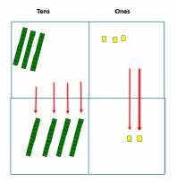  Use Base 10 to make the bigger number then take the smaller number away.  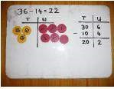  Show how you partition numbers to subtract.  Again make the larger number first. | 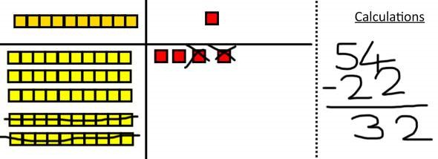  Draw the Base 10 or place value counters alongside the written calculation to help to show working.  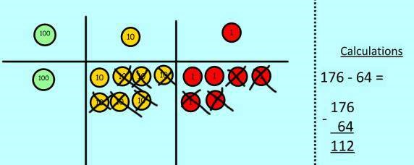 | 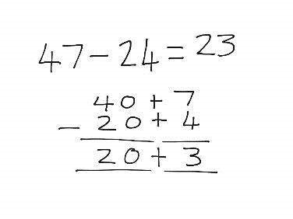  This will lead to a clear written column subtraction.  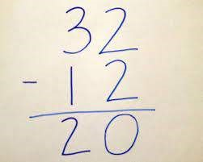

 | Objective | Concrete | Pictorial | Abstract
Year 3  onwards | Column method with regrouping | Use Base 10 to start with before moving on to place value counters. Start with one exchange before moving onto subtractions with 2 exchanges.  Make the larger number with the place value counters  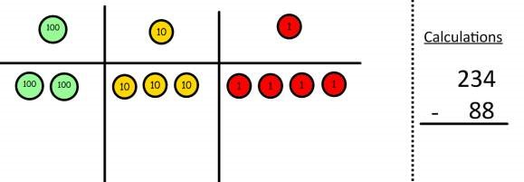  Start with the ones, can I take away 8 from 4 easily? I need to exchange 1 of my tens for 10 ones.  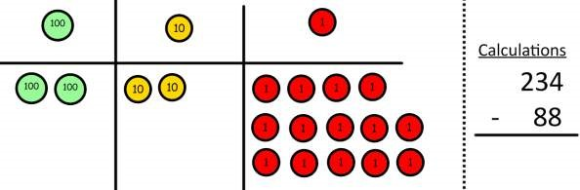  Now I can subtract my ones.  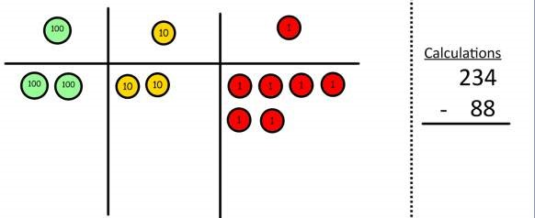 | 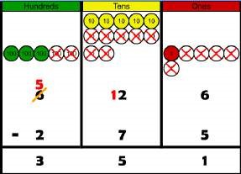  Draw the counters onto a place value grid and show what you have taken away by crossing the counters out as well as clearly showing the exchanges you make.  When confident, children can find their own way to record the exchange/regrouping.  Just writing the numbers as shown here shows that the child understands the method and knows when to exchange/regroup.  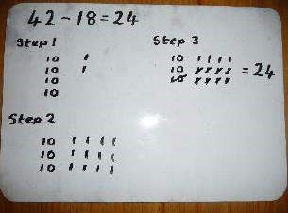 | 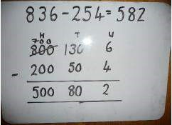  Children can start their formal written method by partitioning the number into clear place value columns.  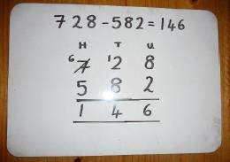  Moving forward the children use a more compact method.  This will lead to an understanding of subtracting any number including decimals.  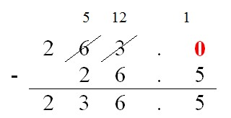

 | Objective | Concrete | Pictorial | Abstract
Year 3 up | Column method with regrouping | Now look at the tens, can I take away 8 tens easily? I need to exchange 1 hundred for 10 tens.  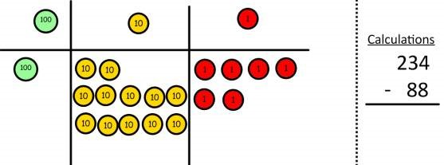  Now I can take away 8 tens and complete my subtraction.  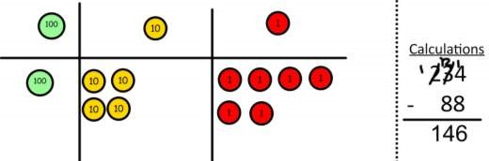  Show children how the concrete method links to the written method alongside your working. Cross out the numbers when exchanging and show where we write our new amount.

 | Objective | Concrete | Pictorial | Abstract
Year 1/2 | Repeated addition | 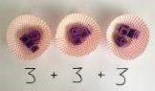  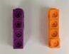  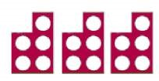  Use different objects to add equal groups. | There are 3 plates. Each plate has 2 star biscuits on. How many biscuits are there?  2 + 2 + 2 = 6  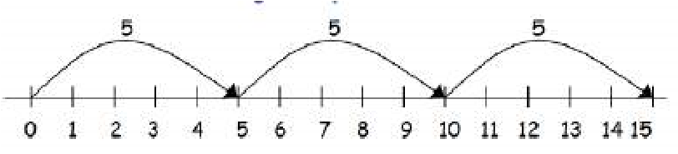  5 + 5 + 5 = 15 | Write addition sentences to describe objects and pictures.  2 + 2 + 2 = 6
 | Arrays  -  showing commutative multiplication | Create arrays using counters/cubes to show multiplication sentences.  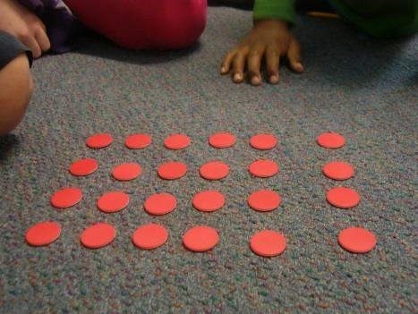  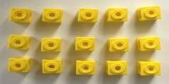 | Draw arrays in different rotations to find commutative multiplication sentences.  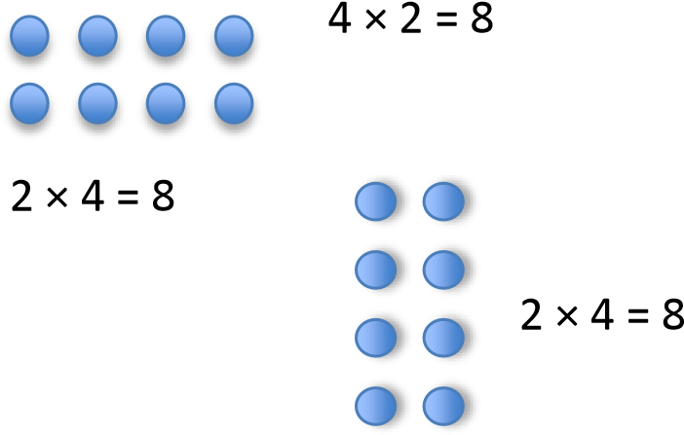  4 × 2 = 8  Link arrays to area of rectangles.  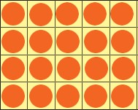 | Use an array to write multiplication sentences and reinforce repeated addition.  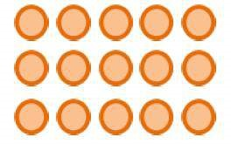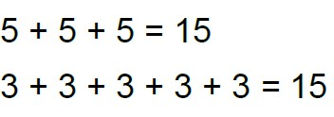  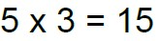  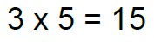

 | Objective |  | Concrete |  | Pictorial |  | Abstract
Year 3/4 | Grid method |  | Show the link with arrays to first introduce the grid method.  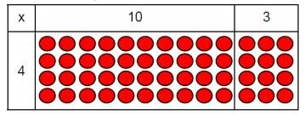  4 rows of 10  4 rows of 3  Move on to using Base 10 to move towards a more compact method.  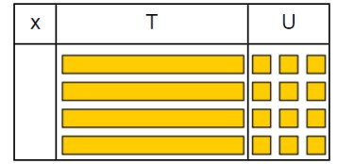  4 rows of 13  Move on to place value counters to show how we are finding groups of a number.We are multiplying by 4 so we need 4 rows.  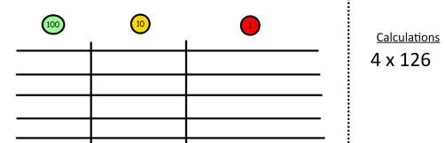  Fill each row with 126.  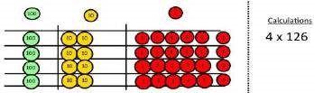  Add up each column, starting with the ones making any exchanges needed.  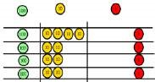4 × 126 = 504 |  | Children can represent the work they have done with place value counters in a way that they understand.  They can draw the counters, using colours to show different amounts or just use circles in the different columns to show their thinking as shown below.  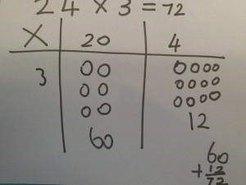 |  | Start with multiplying by one digit numbers and showing the clear addition alongside the grid.  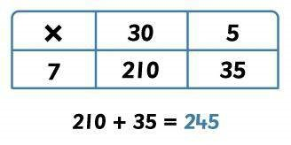  Moving forward, multiply by a 2 digit number showing the different rows within the grid method.  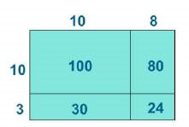  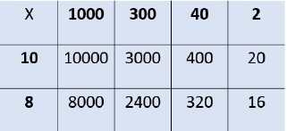
 | Objective | Concrete |  | Pictorial |  | Abstract
 | Expanded method | 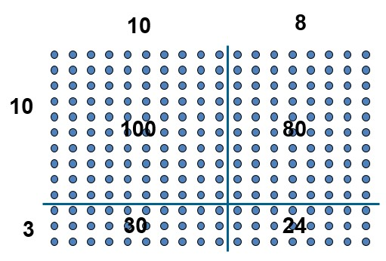  Show the link with arrays to first introduce the expanded method. |  | 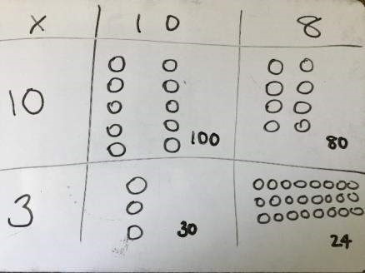 |  | 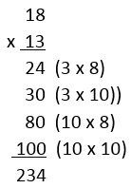  Start with long multiplication, reminding the children about lining up their numbers clearly in columns.
Year 5/6 | Compact method | Children can continue to be supported by place value counters at the stage of multiplication.  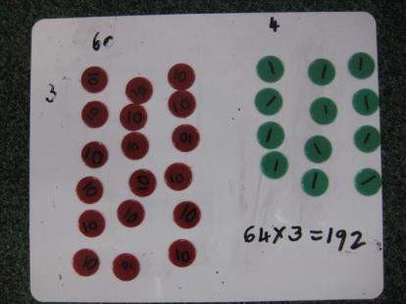  It is important at this stage that they always multiply the ones first and note down their answer followed by the tens which they note below. |  | Bar modelling and number lines can support learners when solving problems with multiplication alongside the formal written methods.  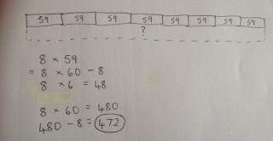  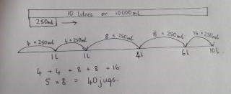 |  | Start with long multiplication, reminding the children about lining up their numbers clearly in columns.  If it helps, children can write out what they are solving next to their answer.  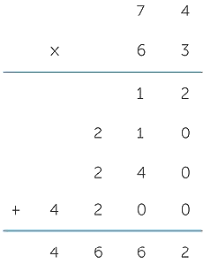  This moves to the more compact method.  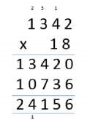

 | Objective | Concrete | Pictorial | Abstract
Year 1/2 | Sharing | I have 8 cubes, can you share them equally between two people? | Children use pictures or shapes to share quantities.  8 ÷ 2 = 4 | Share 8 buns between two people.  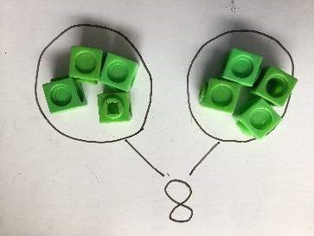  8 ÷ 2 = 4
 | Grouping | Divide quantities into equal groups. Use cubes, counters, objects or place value counters to aid understanding.  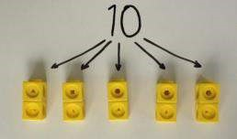  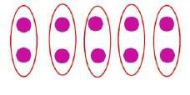 | Use a number line to show jumps in groups. The number of jumps equals the number of groups.  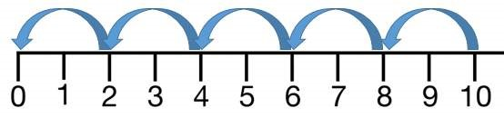  Think of the bar as a whole. Split it into the number of groups you are dividing by and work out how many would be within each group.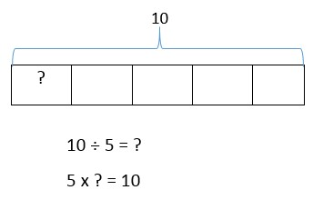 | 10 ÷ 5 = 2  Divide 10 into 5 groups. How many are in each group?

 | Objective | Concrete | Pictorial | Abstract
Year 3/4 | Division with arrays | 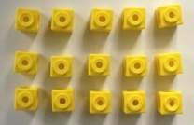  Link division to multiplication by creating an array and thinking about the number sentences that can be created.  Eg 15 ÷ 3 = 5 5 x 3 = 15  15 ÷ 5 = 3 3 x 5 = 15 | Draw an array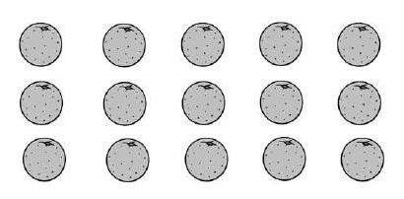 and use lines to split the array into groups to make multiplication and division sentences. | Find the inverse of multiplication and division sentences by creating four linking number sentences.  5 x 3 = 15  3 x 5 = 15  15 ÷ 5 = 3  15 ÷ 3 = 5
 | Short  division | Use place value counters to divide using the short division method alongside.  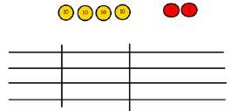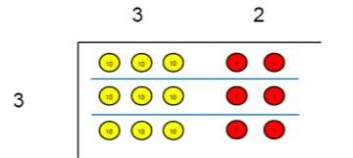  96  ÷  3  42  ÷  3  Start with  the biggest  place value  .  W  e are  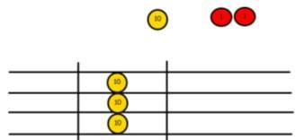  sharing 40 into three groups. We can put 1 ten in each group and we have 1 ten left over.  We exchange  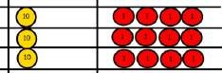  this ten for 10 ones and then share the ones equally among the groups. We look at how many are in each group. | Students can continue to use drawn diagrams with dots or circles to help them divide numbers into equal groups.  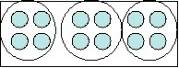  Encourage them to move towards counting in multiples to divide more efficiently. | Begin with divisions that divide equally with no remainder.  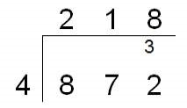

 | Objective | Concrete | Pictorial | Abstract
Year 5/6 | Division with remainders | 14 ÷ 3 =  Divide objects between groups and see how much is left over  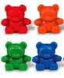 | Jump forward in equal jumps on a number line then see how many more you need to jump to find a remainder.  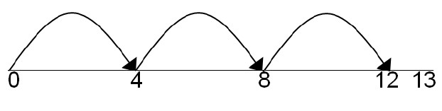  Draw dots and group them to divide an amount and clearly show a remainder.  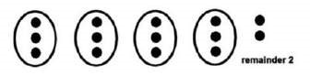 | Complete written divisions and show the remainder using r.  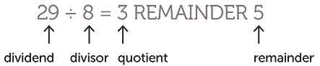
 | Short division with remainders | 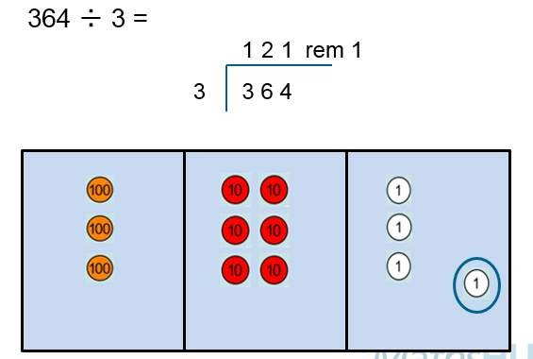 |  | Move onto divisions with a remainder.  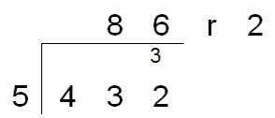  Once children understand remainders, begin to express as a fraction or decimal  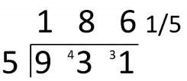  according to the context.  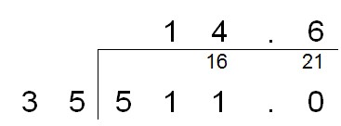

 | Objective | Concrete | Pictorial | Abstract
 |  |  |  | Children will use long division to divide numbers with up to 4 digits by 2 digit numbers.
Year 6 | Long division |  |  | 